
Module 6: Cultural Competency and Anti-Oppression – Participant Handbook

Module 6 Resources: 2
Transcript for Holly Harris’ Video (shown during the Module 6 live session) 3
Information from Module 6 Slides: 4
Homework for Module 6: 6

Module 6 Resources:
Ten Ways to Rock the Rainbow
https://www.peerworks.ca/de/cache/modules_listing/210/rs_Top%20Ten%20Ways%20to%20Rock%20the%20Rainbow%20Webinar%20v2.pdf

Indigenous Peer Support
https://www.peerworks.ca/de/cache/modules_listing/218/rs_Indigenous%20Peer%20Support_2020%20v2.pdf

Kimberlé Crenshaw’s TED Talk “The Urgency of Intersectionality”
https://www.ted.com/talks/kimberle_crenshaw_the_urgency_of_intersectionality#t-73658
PeerWorks Blog Posts:
- “In an Ongoing Pandemic Affordable Access to Technology is a Public Health Issue”
https://www.peerworks.ca/resources/blog/in-an-ongoing-pandemic-affordable-access-to-technology-is-a-public-health-issue
- “Black Mental Health Matters: Resources for Learning and Change.”
https://www.peerworks.ca/resources/blog/black-mental-health-matters-resources-for-learning-and-change
- “Addressing the Rise of Anti-Asian Racism and Supporting Asian-Canadian Community Members.”
https://www.peerworks.ca/resources/blog/addressing-the-rise-of-anti-asian-racism-and-supporting-asian-canadian-community-members

Transcript for Holly Harris’ Video
(shown during the Module 6 live session)

Hello, my name is Holly Harris, and I am a post-secondary peer support specialist working at a tertiary mental health care facility in Ontario. I leverage my lived experience with mental health challenges to inform the planning, development and delivery of recovery college programming in post-secondary institutions. Coupled with this lived experienced, I have leveraged my professional and academic experiences related to mental health research and critical disability studies to ensure that the voices of those with lived experiences are at the forefront of program development and delivery.

Practicing peer support has been so impactful on my own wellness journey. I have found a wonderful community and made amazing connections within this peer community. I am consistently learning about the diversity and complexity of the human experience. I appreciate the fact that no one asks for mentally distressing experiences. So, isn’t it fair to say that it is part of the human experience? If we connect as humans, we can erase power differentials that are inherent in the psychiatric system and empower each other to leverage distressing experiences to connect in new ways and find new meaning and purpose.

One story I love to tell is one that a colleague shared with me. When a service user at our institution was asked what the best part of their day was, their answer was: when a nurse engaged them in conversation about their dogs. I think connected as people is so essential in promoting wellness, and erasing social distance and dismantling stigma.

I am so passionate about practicing peer support in a way that recognizes, affirms and values the diversity of perceptions and experiences with mental health, wellness, and mental distress. This involves practicing in a way that is trauma-informed, culturally competent, while acknowledging our privilege and practicing accountability. It is important to reflect on our backgrounds and experiences that we bring to the table, and recognize the strengths that are afforded by those experiences so that we can play to them.

But it is also important to recognize the biases that we carry as well. We can acknowledge our privilege by doing our research and holding ourselves accountable. We can commit to making our communities safer spaces. I say ‘safer’, because we can’t commit and promise a ‘safe space.’ We can’t be 100% certain that harm won’t occur due to the diversity and complexity of the human experience, but we can do our best. And if harm does occur, we can hold ourselves accountable.

Thank you so much

Information from Module 6 Slides:

Diversity is relational. No individual person is diverse, but we can have a diverse community or organization. This means that our community includes a large number of perspectives, experiences and identities. Diversity refers to the unique characteristics that all of us possess, both distinguishing us as individuals and identifying us as belonging to different groups. Diversity embraces the richness inherent in people’s race, ethnicity, socio-economic status, gender, religion, sexual orientation, family identification, immigration status, functional ability and age.

Inclusion It isn’t enough to have a variety of people involved, they need to feel welcomed and respected. This is what is meant by inclusion. Inclusion involves designing our space in order to make everyone feel valued and have their needs met.

Cultural Competency is the ability to interact effectively and comfortably with people from different cultures.

Unconscious Bias: also known as implicit bias, is a bias that someone might not be aware they have.

Microaggressions: subtle, unconscious or indirect forms of discrimination against a marginalized group.

Sexual orientation describes the way a person feels toward people of a particular (or more than one) gender both physically and emotionally. Ex: heterosexual, bisexual, homosexual, asexual, queer, etc.

Gender identity describes the way a person feels about their gender — including their body — and the ways they feel they’re expected to behave within that body. Ex: cisgender, transgender, and nonbinary.

LGBTQ2+
L – Lesbian: a female-identified person who is physically and emotionally attracted to other females.
G – Gay: a male-identified person who is physically and emotionally attracted to other males. Gay is also used as a broad term to describe people attracted to someone of the same gender.
B – Bisexual/Bi: a person who is physically and emotionally attracted to people of more than one gender and who identifies as bisexual (bi).
T – Transgender/Trans: transgender (trans) is a term used by people who identify with a gender that is different from the gender they were assigned at birth. People whose gender identity falls outside of the gender binary (the idea that there are only two genders — male and female) may also call themselves trans. Since trans is a word used to describe identity, a person has to identify with the term (believe it’s the best way to describe themselves) for it to be applicable. No one else can decide a person is or isn’t trans. Other terms to describe gender identity that may be preferred by some people include genderqueer, gender fluid and androgynous.
Trans is not a sexual orientation — it’s a gender identity. “T” (for transgender/trans) is grouped with the sexual orientations in LGBTQ2S+ for many reasons, including shared civil and human rights activism and similar experiences of discrimination.
Q – Queer: queer is a broad term that includes all sexual orientations and gender identities within the LGBTQ2S+ community, including those who don’t identify with any other identity in LGBTQ2S+. The term queer can be both positive and negative. Historically, queer was used as an insult, but it has been reclaimed by the LGBTQ2S+ community to self-identify in a positive way.
Q – Questioning: some people may feel unsure about their sexual orientation and/or gender identity. They may describe themselves as questioning. They may be questioning until they identify with a particular identity or continue to be questioning throughout their lives.
Two-Spirit (2 Spirit or 2S): a person with both a feminine and a masculine spirit living in the same body. It’s an important term within some Indigenous cultures and some Indigenous people use it to describe their sexual orientation, gender identity and/or spiritual identity.

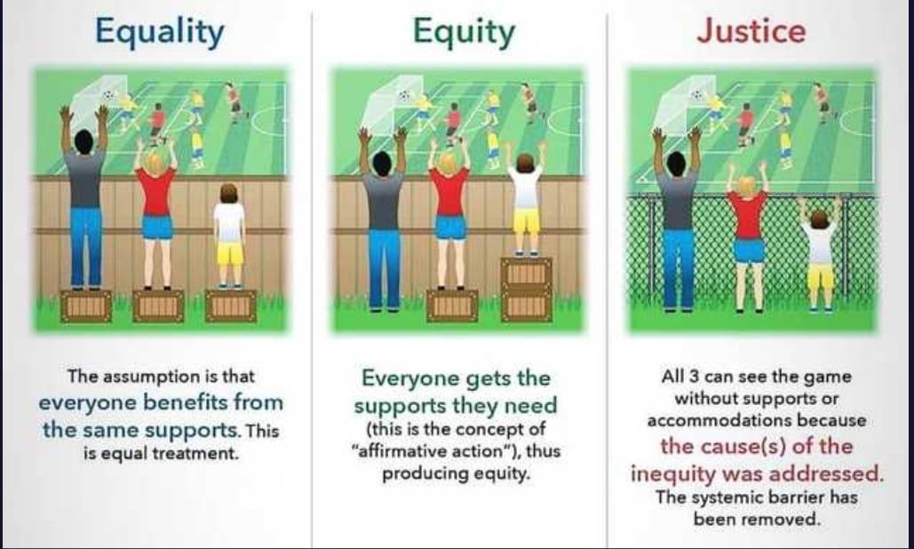

Homework for Module 6:

Research a community resource that is local/accessible to you. Learn about the services that this resource offers and take notes that include information on how to connect to this resource.

Please e-mail your resource to [Training Coordinator] at [email@peerworks.ca] with the subject line “Your Name Resource.” e.g. “Allyson Resource.”

Please complete this homework before Module 7.

